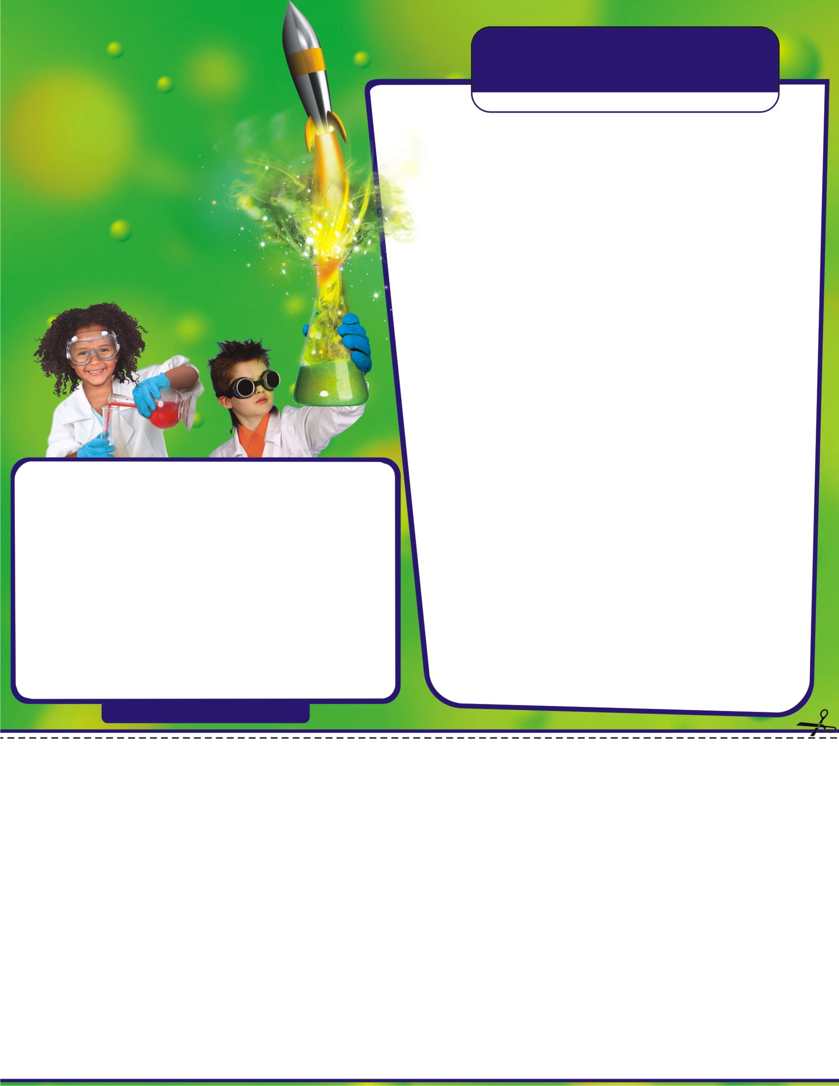
CRAZY CHEMWORKS
Students will participate in 6 of the following 8 exciting sessions

Lab Works - Become a real Mad Scientist in this whirlwind class on how a lab works! Learn to manipulate laboratory equipment at your personal lab bench, and take home your very own Graduated Gear to continue your research!

Junior Reactors – Dive into a tiny world of atoms and learn to recognize chemical reactions and mix up a few reactive ingredients for some sensational results! Continue experimenting at home with a beaker for your home lab!

pH Phactor - Slide down the colorful pH scale and dip into the world of acids and bases! Explore the pH extremes with your Reaction Tube in what is sure to be a popping experience! Discover whether liquids found in your home are acids or bases using your own personal pH Paper!

Slime Time - Ooze into a gooey hour of sliming around! Create slime using the Mad Science recipe, and then enter the Slime Olympics! Take home your own concoction of Mad Science Slime!

Chem in a Flash - Hop on board the chemistry express for a high-speed science experience! Perform instantaneous experiments in this fast-paced class on split-second reactions that go like mad! Pick up an Action Flask and have a blast !

The Glow Show - Discover amazing things that glow bright in the dark and come to light! Probe the properties of light and explore some unusual applications of glow-in-the-dark technology!
Super Sticky Stuff - Stick to the walls, build a bond with glue and push the power of tape to the limits in this adhesive hour on things that cling!

Dry Ice Capades - Manipulate matter in all of its three states! Melt metal in boiling water and freeze water in a flash with dry ice! Use your Thermocolor Cup to test the temperature of liquid matter in your home!

A Take home for every session!

ONLINE REGISTRATION ONLY- register and pay online on our Website:
Mad Science of Greater Tampa Bay
Go to http://GreaterTampaBay.MadScience.Org Select “ PARENTS” then “AFTERSCHOOL PROGRAMS” then “REGISTER NOW” – Then find your school and fill out the form and submit .

Registration Deadline: Friday Feb 9th
Limited space! Registration is on a first come first served basis.

Pinellas County Schools is neither sponsoring nor affiliated with this event

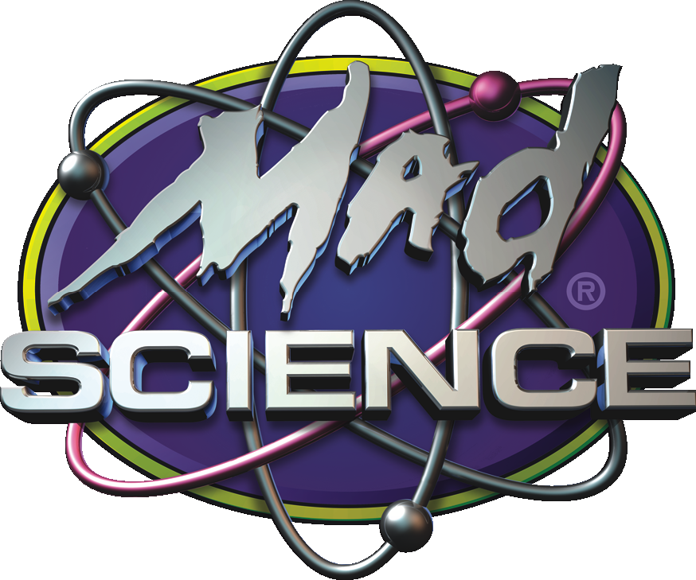
GREATERTAMPABAY.MADSCIENCE.ORG

Gulf Beaches Elem Mad Scientists Club

(Grades K-5)
When: Tuesdays 3:05–4:05pm, Feb 13th – March 26th (Skip March 12th)
How Long: (6 sessions)
Where: Gulf Beaches Elementary
Cost: $99 per child (online only – before Deadline- see below)
Questions?
Email us at Madsciencegreatertampabay@gmail.com

